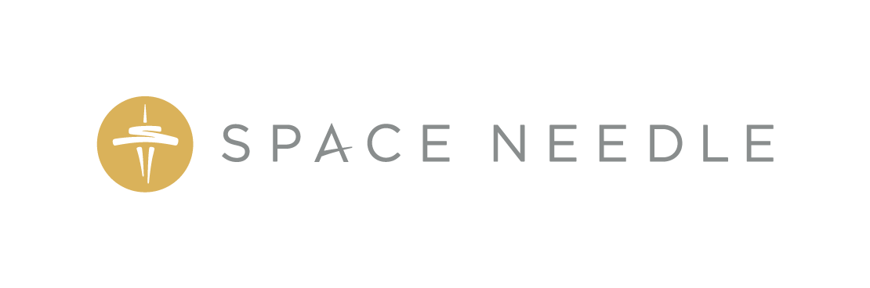
FOR IMMEDIATE RELEASE

Do Not Open Until 2062: Space Needle Calls for Memorabilia and Predictions for Seattle’s Most Iconic Time Capsule
Public will have the chance to include their own personal treasures in time capsule that won’t be opened for 43 years

SEATTLE, WA —Thursday, May 9, 2019 — In celebration of the past, present and future, the Space Needle is launching a nationwide search for items that provide a snapshot of life in 2019 and predictions for the future, which will be sealed in its new time capsule later this year. The Seattle icon will also offer the general public the chance to add their own personal treasures or memories into the time capsule through an online contest.
The array of items collected for the time capsule will reflect the people and culture of Seattle and beyond. While several of the items that will be added to the time capsule will remain a secret until it is opened in 2062, the Space Needle revealed a few items, which include:

- Personal messages from Seattle-based band Pearl Jam
- Super Bowl predictions from Seattle Seahawks legend Walter Jones
- A sheet of United States Postal Service Forever Stamps
- One share of Amazon.com stock
- And of course, a Twinkie

Made of stainless steel and aluminum, the time capsule weighs more than 160 pounds, stands 42” tall and is 16” in diameter. The time capsule is scheduled to be sealed on October 21, 2019 and will be opened on April 21, 2062—the Space Needle’s 100th anniversary.
“Since we opened our doors for the World’s Fair in 1962, the Space Needle has always been both a beacon of the future and a place to create lasting memories,” said Space Needle Chief Marketing Officer Karen Olson. “Our time capsule contest will give people living in the future a snapshot of our lives today, and continues our legacy of inspiring wonder and possibility.”
The time capsule contest opens today and offers six lucky participants the opportunity to share personal items, treasures, or predictions with people living in 2062. To participate — and for details and rules — visit www.spaceneedle2062.com and tell the Space Needle jury what you would include in the time capsule and why. Additionally, the public is invited to share ideas about other items to be included in the time capsule and can do so by using the hashtag #SeeYouin2062 on Facebook, Instagram and Twitter.
The Space Needle will continue to collect items through Friday, September 13, 2019 before the time capsule is officially sealed during a special ceremony in Monday, October 21, 2019. Once the time capsule is closed, it will be displayed inside the tower until it’s opened on the Space Needle’s 100th anniversary on Friday, April 21, 2062.
###

CONTACT:
Dave Mandapat, Space Needle:
Email: davem@spaceneedle.com
Desk: 206-905-2164
Cell: 206-605-8637

Danielle Winslow, Space Needle:
Email: daniellew@spaceneedle.com
Desk: 206-905-2139
Cell: 206-498-3560

About Space Needle
Built as the centerpiece and inspiration for the 1962 Seattle World’s Fair, the Space Needle has since become a part of the Seattle experience and the globally-recognized icon for the city. The Space Needle’s recent renovation added more than 176 tons of glass to the structure, offering unparalleled views of Seattle. The historic transformation now houses The Loupe—the world’s first revolving glass floor. Open year-round, the Space Needle hosts more than a million visitors per year. For more information visit: www.spaceneedle.com/press.

